Equality and American Democracy

Why Politics Trumps Economics
By Danielle Allen

Since the trend toward rising economic inequality in the United States became apparent in the 1990s, scholars and commentators have heatedly debated its causes and consequences. What has been less evident is a vigorous positive discussion about what equality means and how it might be pursued.
Up through the middle of the nineteenth century, Americans saw equality and liberty as mutually reinforcing ideals. Political equality, shored up by economic equality, was the means by which democratic citizens could secure their liberty. The Declaration of Independence treats the equal capacity of human beings to make judgments about their situations and those of their communities as the basis for popular government and identifies the people’s shared right to alter or abolish existing political institutions as the only true security for their freedom. And Abraham Lincoln famously summed up the founding as the birth of a nation “conceived in Liberty, and dedicated to the proposition that all men are created equal.”

As the historian James Hutson has shown, many of the founders understood the achievement of political liberty to require some meaningful degree of economic equality. One of the most important policy achievements of the era was the elimination in most states of primogeniture laws, a favorite cause of Thomas Jefferson. Thomas Paine advocated giving a cash grant to every man and woman on turning 21 and an annual pension to every person aged 50 and older, both to be funded through an estate tax. And even John Adams, who thought that the franchise should be limited to property holders, nonetheless believed that class should be defined as broadly as possible in order to avoid turning the new country into an oligarchy. In May 1776, he wrote to a fellow politician, “The only possible Way then of preserving the Ballance of Power on the side of equal Liberty and public Virtue, is to make the Acquisition of Land easy to every Member of Society: to make a Division of the Land into Small Quantities, So that the Multitude may be possessed of landed Estates.”
The founders didn’t just espouse economic equality; they lived it. According to the historian Allan Kulikoff, at the time of the Revolution, more than 70 percent of white households in western counties, such as the Piedmont area of Virginia and newly settled regions of Maine, New Jersey, Pennsylvania, and even New York, owned land. In eastern counties, property ownership had started to slip but still neared 60 percent. The new nation’s successful development of political equality and liberty rested on a historically unprecedented level of economic equality within the white population.
The country’s leaders, moreover, chose to perpetuate this situation through public policy. The egalitarian land distributions arranged in the Northwest Territory through the land ordinances of the 1780s may be the most famous case, but they were not alone. From 1805 to 1833, for example, Georgia distributed most of its land to white men, widows, and orphans through random lotteries.
But this, of course, is where the story turns sour. Where did Georgia’s officials get that land to give away? From Native Americans, driven out of their homes thanks to the strenuous efforts of Andrew Jackson and others. Georgia’s remarkably equal distribution of property is thus known by historians as “the Cherokee land lottery.” Both the levelers among the founders and their critics agreed on where the wealth necessary for the new nation would come from: the expropriation of Native Americans, as well as from slave and indentured labor.
When the French traveler Alexis de Tocqueville visited the United States in the early 1830s, he was struck by the egalitarian nature of the young nation—both in its culture and in the distribution of wealth. And many in those days recognized that in order for political equality to persist over time, it needed to be matched by some degree of economic equality. This is no less true today than it was then. Now, however, Americans must find a way to achieve such equality without relying on extraction and appropriation.
LIBERTY VS. EQUALITY
In contrast to the early years of the republic, during which equality and liberty were understood to reinforce each other, by the middle of the twentieth century, it had become commonplace to invoke the idea of an “eternal conflict” between the two values, as a classic 1960 libertarian article put it. What happened in the interim? The rise of industrialization, which changed the balance of power among land, labor, and capital.
Responding to the transformations they saw around them in the early days of the Industrial Revolution, Marx and Engels predicted in The Communist Manifesto that “the proletariat will use its political supremacy to wrest, by degrees, all capital from the bourgeoisie, to centralize all instruments of production in the hands of the State.” They continued: “Of course, in the beginning this cannot be effected except by means of despotic inroads on the rights of property and on the conditions of bourgeois production.” Although Marx described his goal with the vocabulary of emancipation, his cause became linked to the ideal of equality—which soon lost its political meaning and came to be generally understood in economic terms. Economic equality thus came to be seen as something achievable only via “despotic inroads” on liberties such as the right to property. Fusing this with social Darwinism, the late-nineteenth-century thinker William Graham Sumner captured the new view succinctly: “Let it be understood that we cannot go outside of this alternative: liberty, inequality, survival of the fittest; not-liberty, equality, survival of the unfittest.”
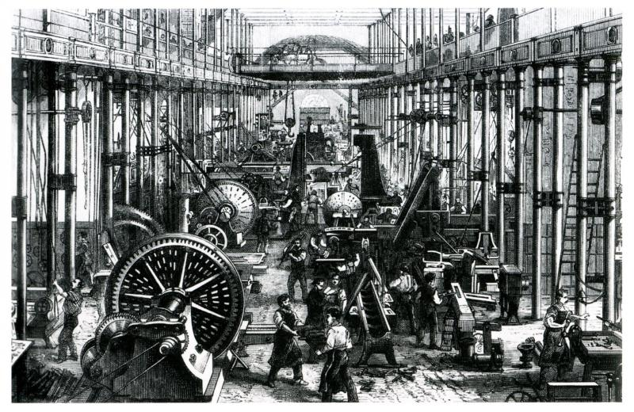
WIKIMEDIA COMMONS
An engineering company in Germany during the Industrial Revolution, 1868.
The idea that liberty and equality are necessarily in conflict with each other became a staple of Cold War rhetoric that cast free-market capitalism (alongside religiosity) as the defining feature of the political system of the United States and totalitarian equalization (alongside atheism) as the defining feature of the Soviet Union.
In American public discourse, clichés abound for expressing what freedom means. “Give me liberty or give me death.” “Don’t tread on me.” “It’s a free country.” “A man’s home is his castle.” “Doing what you like is freedom; liking what you do is happiness.” But clichés about equality are much rarer, pretty much limited to “All men are created equal” and “One person, one vote.” George Orwell argued that clichés indicate the corruption of thought by politics; speakers relying on them reveal an absence of original mental effort. But surely the absence of clichés indicates an even greater absence of thought. There are so few clichés about equality because Americans have spent so little time dwelling on the subject.
SPHERES OF JUSTICE
The first task in any project of recovering an ideal of equality is to recognize that the concept requires further specification. When speakers invoke equality, do they mean moral, political, social, or economic equality? Even in the economic sphere alone, are they concerned with equality of outcomes or of opportunity? And what do they assume about the relationships among these different types of equality, or “spheres of justice,” as the political theorist Michael Walzer has dubbed them?
Moral equality is the idea that all human beings have the same fundamental worth and deserve the same basic protection of rights. The framework of international human rights law rests on and captures this idea.
Political equality is the ideal that all citizens have equal rights of access to political institutions. It is most commonly defined as requiring civil and political rights—to freely associate and express oneself, to vote, to hold office, and to serve on juries. These are important rights, and protecting them from infringement is critical. But a richer notion of egalitarian empowerment would also consider whether society is structured so as to empower citizens to enter the fray of a politically competitive system. Questions about a right to education, for instance, would come in here, as would questions about campaign finance and electoral redistricting, which could impede the potential for truly democratic representation.
Social equality involves the quality of social relations and associational life. Are neighborhoods integrated? Do equally qualified individuals have equal chances at jobs and valuable positions in society? During the civil rights movement, African American activists often had to set aside any claim to be pursuing social equality in order to get whites to support a project of securing political equality. The bargain was, to put it crudely, that the vote, the lunch counter, and public schools could be desegregated as long as that did not lead to greater rates of interracial marriage or social relations. Of course, that wasn’t true, but at that point, explicit pursuit of social equality was a bridge too far. The Black Lives Matter campaign has now put the question of social equality squarely on the table, where it ought to have been all along.
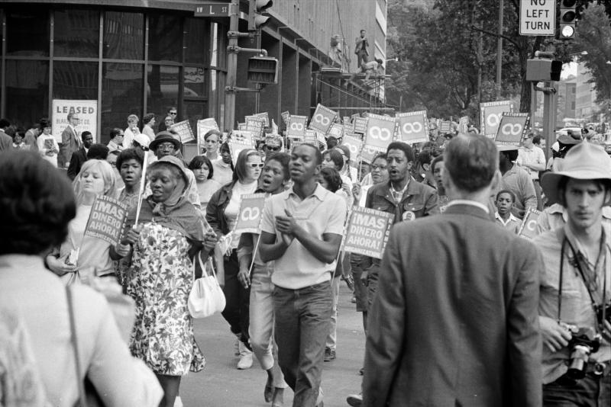
WIKIMEDIA COMMONS
Demonstrators in the Poor People's March at Lafayette Park and Connecticut Avenue in Washington, D.C., June 1968.
Economic equality, finally, has come to the fore thanks to recent trends, with all the complexities and conundrums of its lack. There is now a broad consensus, for example, that straight equalization of economic resources can be achieved only at the cost of extreme, unjust, and counterproductive restrictions on personal liberty and a significant reduction of aggregate economic growth. This doesn’t mean, however, that no egalitarian economic policy is possible, nor does it excuse us from trying to introduce into economic policy discussions notions of justice, fairness, and opportunity. The political philosopher John Rawls, for example, made compelling arguments that it is moral to pursue economic policies that generate inequalities, but only if they benefit the worse off in absolute terms, or at least do them no absolute harm.
Treating each domain of equality on its own terms has its uses. But it is also important to treat them together, asking how they relate to one another and how they should be prioritized.
POLITICS FIRST
The early-nineteenth-century political philosopher Benjamin Constant famously argued that there was a critical difference between the liberty of the ancients and that of the moderns. The ancients, he averred, sought above all the freedom to participate in politics and to control their institutions, whereas the moderns preferred to be free from the burdens of politics in order to pursue their commercial enterprises and material pleasures. (Americans heard a strange echo of this argument when U.S. President George W. Bush, in the wake of the 9/11 attacks, called on them to continue their commercial activity in fulfillment of their civic duty.)
In modern mass democracies, it is indubitably harder to participate meaningfully in politics than it would have been in ancient Greek city-states or even republican Rome. This fact has led philosophers from John Stuart Mill to Isaiah Berlin to Rawls to accept the view that what we really need are experts who can set up a framework to protect citizens’ liberties and material interests while they go about the business of living as they choose.
Yet this is to ask people to abandon the most powerful instrument available to them to effect their safety and happiness, namely politics. For if there is now a consensus that full equalization of economic resources would require extreme and costly restrictions on liberty, there is also now a consensus that there is no such thing as a totally free market. To function well, markets depend on rules, norms, and regulations, backed by law and the power of the state, and it is politics that determines what those rules, norms, and regulations will be. Politics trumps economics, in other words, or at least sets the terms according to which the economic game is played. So discussions of economic equality cannot be contained within the economic sphere alone and need to come back around, in the end, to the political sphere.
Discussions of political equality, in turn, can and should bring economics into play, including the prospect of political contestation around issues of economic fairness. In other words, policies that secure political equality can have an effect on income inequality by increasing a society’s political competitiveness and thereby affecting “how technology evolves, how markets function, and how the gains from various different economic arrangements are distributed,” as the scholars Daron Acemoglu and James Robinson have noted. This is precisely the linkage the economist Amartya Sen called attention to with his research on the politics of famine in India, pointing out that there were some mass starvations under colonialism, despite the country’s great agricultural fertility, but there have not been any under democracy.
And there are other, even more important reasons for prioritizing political equality, such as the argument from moral equality that the best way to ensure that each person can be the author of his or her own life is by giving everyone an ownership stake in political institutions. Approaching egalitarianism through political equality rather than other routes leads to two further questions: How does one’s status within the political realm relate to one’s status in other spheres, and how can political equality itself be secured?
HOW TO PROMOTE POLITICAL EQUALITY
In his treatment of the spheres of justice, Walzer argued for ensuring that one’s status in each domain support, or at least not undermine, one’s status in the other domains. We should seek economic and social policies, for example, that build a foundation for political equality, and as a result, even though we will not find ourselves strictly equal in the economic realm, or even the social one, a rough equality there could support our political equality and permit us to achieve a “complex equality” more generally. But what, precisely, is required of the relations among the three spheres?
Political equality ultimately rests not on the right to vote or the right to hold office but on the rights of association and free expression. It is these rights that support contestation of the status quo, whether that is maintained by the government or by social majorities. The right to contract, meanwhile, is itself also deeply embedded in the right to association. But the moment that societies protect association, expression, and contract, as they must in order to protect human dignity at its most fundamental, they also secure two other phenomena: social discrimination and capitalism. Out of the right of association, socially differentiated groups form, and lines of difference can easily evolve into lines of division and domination. The requirements of political equality, in other words—freedom of association, expression, and contract—generate social phenomena that potentially jeopardize social equality and can lead to economic exploitation.
How, then, can we build institutional frameworks in the social and economic domains that guide our associational practices in the direction of social equality and our economic practices in the direction of egalitarianism? We need a virtuous circle in which political equality supports institutions that, in turn, support social and economic equality—for without those frameworks, the result could well be the emergence of social castes or economic exploitation, either of which would feed back to undermine political equality.
Rising to such a challenge is clearly difficult, but the basic issues involved can be sketched simply. The two fundamental sources of power in a democracy are numbers and control over the state’s use of force. The media have access to eyeballs and ears, and therefore to numbers. Wealth, celebrity, and social movement organization can also provide access to eyeballs and ears. Wealth secures that access indirectly, by buying media resources; celebrity brings it directly. Organizing can also achieve such access, but only by dint of hard work. And wealth can also sometimes buy access to institutional control.
Many argue that the most important step needed to restore political equality now is to check the power of money in politics through campaign finance reform or to equalize the resources available to political actors by publicly subsidizing campaigns. They have a point, but by themselves such remedies are insufficient because they focus on only part of the broader picture. Reformers should be considering not merely how to check the power of money in politics but also how to rebuild the power of organizers and organizing as a counterbalance to wealth.
A smart path toward this goal has been identified by the Yale law professor Heather Gerken, who argues for a new federalism that maps out consequential policy domains at all levels of the political system and supports citizen engagement at each level. Gerken’s project is not about states’ rights; the federal rights enforcement structure would continue to establish the rules of the game for engagement at the local level. But she correctly points out that significant power resides throughout the various layers of U.S. politics and that there are rich egalitarian possibilities in all sorts of areas, from zoning, housing, and transportation to labor markets, education, and regulation. Policy contestation at the local and regional levels, she notes, can drive changes at the national level, with the case of marriage equality being only the most recent prominent example.
Bolstering political equality throughout the lower and middle layers of the U.S. federalized political system is a not an easy or sexy task, but that is what is required to redress the outsize power of money in national life that has been both the consequence and the enabler of rising economic inequality. Liberty and equality can be mutually reinforcing, just as the founders believed. But to make that happen, political equality will need to be secured first and then be used to maintain, and be maintained by, egalitarianism in the social and economic spheres as well.

